NAND gate as an OR gate :

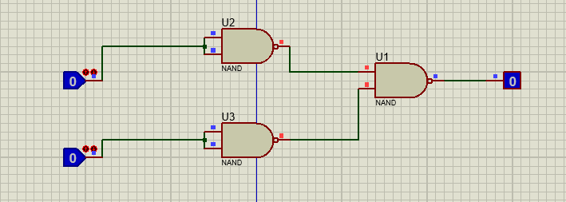

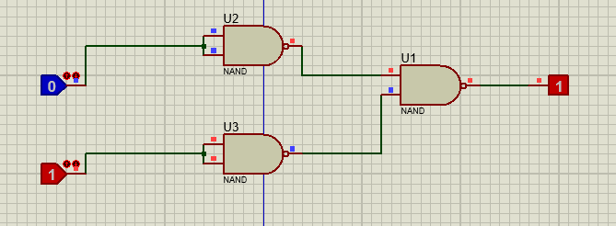

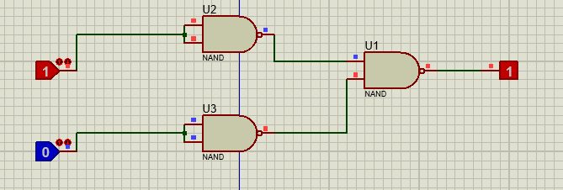

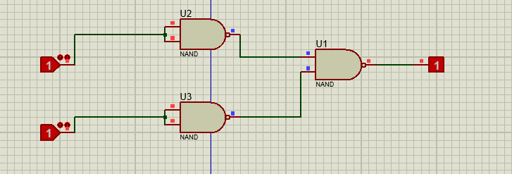

NAND gate as an AND gate :

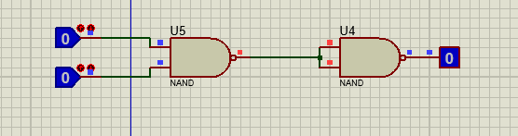

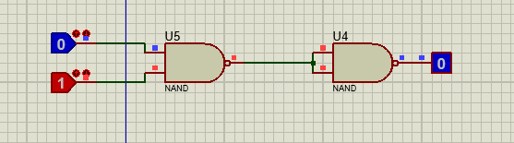

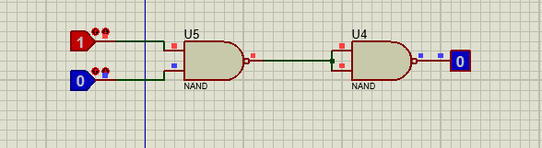

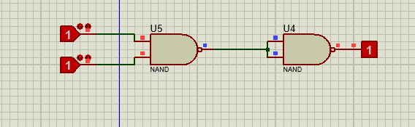

NAND gate as a NOT gate :

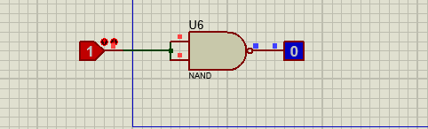

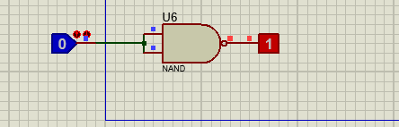

NOR gate as an AND gate :

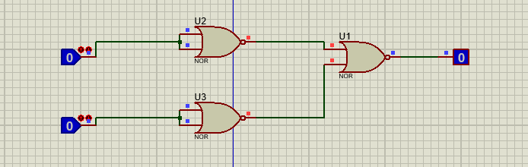

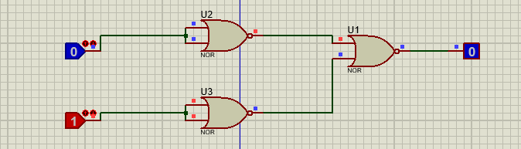

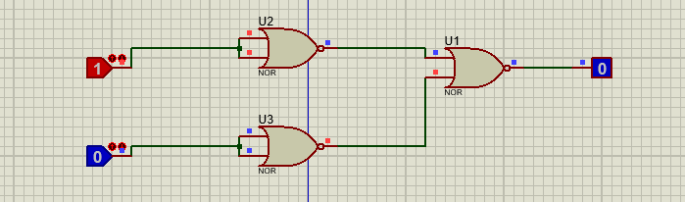

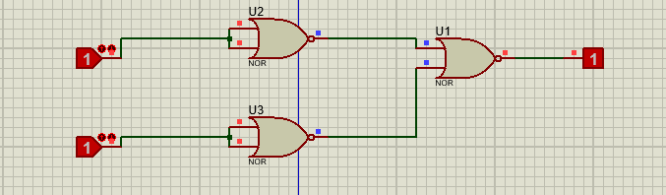

NOR gate as an OR gate :

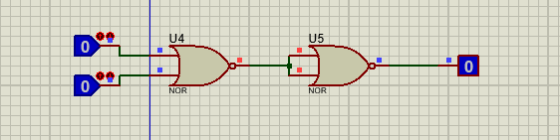

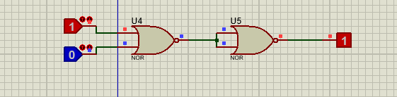

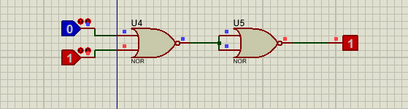

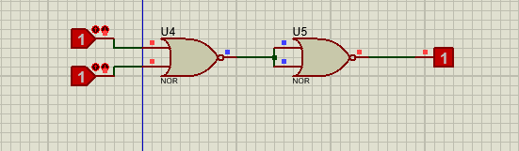

NOR gate as a NOT gate :

